CSS Syntax

A CSS rule set consists of a selector and a declaration block:

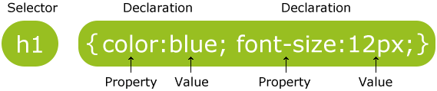

The selector points to the HTML element you want to style.

The declaration block contains one or more declarations separated by semicolons.

Each declaration includes a property name and a value, separated by a colon.

CSS Example

A CSS declaration always ends with a semicolon, and declaration groups are surrounded by curly braces:

p {color:red;text-align:center;}

To make the CSS code more readable, you can put one declaration on each line.

In the following example all <p> elements will be center-aligned, with a red text color:

Example

p {  
    color: red;  
    text-align: center;  
}

[Try it yourself »](http://www.w3schools.com/css/tryit.asp?filename=trycss_syntax1)

CSS Comments

Comments are used to explain the code, and may help when you edit the source code at a later date. Comments are ignored by browsers.

A CSS comment starts with /* and ends with */. Comments can also span multiple lines:

Example

p {  
    color: red;  
    /* This is a single-line comment */  
    text-align: center;  
}  
  
/* This is  
a multi-line  
comment */